Problem no: -1 Neural Networks and Deep Learning

Date: - 12.01.2026
Experiment No:- 3
Credit Card fraud Detection System
Source Code:
import kagglehub
import os
import pandas as pd
import numpy as np
import matplotlib.pyplot as plt
import seaborn as sns
from sklearn.model_selection import train_test_split
from sklearn.preprocessing import StandardScaler
from sklearn.metrics import recall_score, f1_score, confusion_matrix
import tensorflow as tf
from tensorflow.keras.models import Sequential
from tensorflow.keras.layers import Dense
from tensorflow.keras.optimizers import Adam
path = kagglehub.dataset_download("kartik2112/fraud-detection")
print("Path to dataset files:", path)
files = os.listdir(path)
print("Files in dataset:", files)
df = pd.read_csv(os.path.join(path, "fraudTrain.csv"))
print("Dataset Loaded:", df.shape)
df = df.drop(columns=[
'Unnamed: 0', 'trans_date_trans_time', 'cc_num',
'merchant', 'category', 'first', 'last',
'gender', 'street', 'city', 'state',
'zip', 'lat', 'long', 'city_pop',
'job', 'dob', 'trans_num'
])
X = df.drop("is_fraud", axis=1)
y = df["is_fraud"]
X_train, X_test, y_train, y_test = train_test_split(
X, y,
test_size=0.3,
random_state=42,
stratify=y
)
scaler = StandardScaler()
X_train = scaler.fit_transform(X_train)
X_test = scaler.transform(X_test)
model = Sequential([
Dense(32, activation='relu', input_shape=(X_train.shape[1],)),
Dense(16, activation='relu'),
Dense(1, activation='sigmoid')
])
model.compile(
optimizer=Adam(learning_rate=0.001),
loss='binary_crossentropy'
)
model.summary()
history = model.fit(
X_train, y_train,
epochs=20,
batch_size=256,
validation_split=0.3,
verbose=1
)
plt.figure()
plt.plot(history.history['loss'], label='Train Loss')
plt.plot(history.history['val_loss'], label='Validation Loss')
plt.xlabel("Epoch")
plt.ylabel("Loss")
plt.title("Loss Curve")
plt.legend()
plt.show()
y_pred_prob = model.predict(X_test)
y_pred = (y_pred_prob >= 0.6).astype(int)
print("Recall Score:", recall_score(y_test, y_pred))
print("F1 Score:", f1_score(y_test, y_pred))
cm = confusion_matrix(y_test, y_pred)
plt.figure()
sns.heatmap(
cm,
annot=True,
fmt='d',
cmap='Blues',
xticklabels=['Normal', 'Fraud'],
yticklabels=['Normal', 'Fraud']
)
plt.xlabel("Predicted")
plt.ylabel("Actual")
plt.title("Confusion Matrix")
plt.show()
RESULT
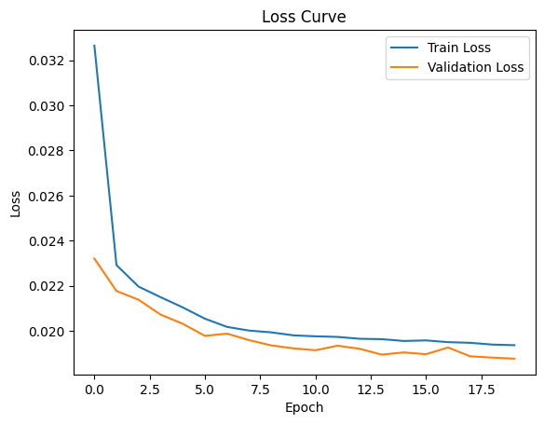
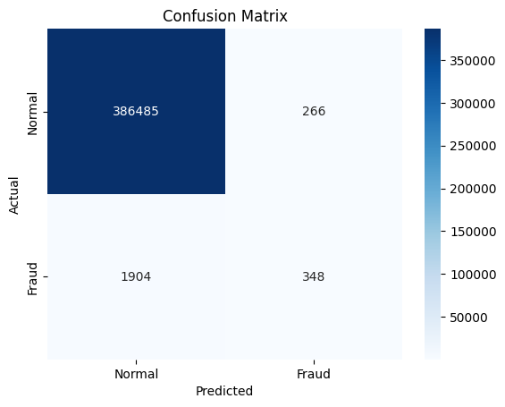

Name: - Jaya Shankar Reddy
Reg no: - 2023BCSE07AED381

